**PROJECT BASED LAB REPORT**

**On**

**BANKING SYSTEM**

**Submitted in partial fulfilment of the**

**Requirements for the award of the Degree of**

**Bachelor of Technology**

**in**

**ELECTRONICS AND COMMUNICATION ENGINEERING**

**By**

**ROHINI PANDIRI 2100031934**



**DEPARTMENT OF ELECTRONICS AND COMMUNICATION ENGINEERING**

**K L University**

Green Fields, Vaddeswaram, Guntur District-522 502

**2016-2017**

**K L University**

**DEPARTMENT OF ELECTRONICS AND COMMUNICATION ENGINEERING**



***CERTIFICATE***

This is to certify that this project based lab report entitled **“BANKING SYSTEM”** is a bonafide work done by  **ROHINI PANDIRI 2100031934** in partial fulfilment of the requirements for the award of degree in **BACHELOR OF TECHNOLOGY** in **ELECTRONICS AND COMMUNICATION ENGINEERING**  during the Academic year 2016-2017.

**Faculty in Charge Head of the Department**

Smt. P.S.G. Aruna Sri(Ph.D) Dr.A.S.C.S.SASTRY

**Project guide**

Mr. D. Bhupesh

**K L University**

**DEPARTMENT ELECTRONICS AND COMMUNICATION ENGINEERING**



***DECLARATION***

We hereby declare that this project based lab report titled **“BANKING SYSTEM”** has been prepared by us in partial fulfilment of the requirements for the award of degree “**BACHELOR OF TECHNOLOGY in ELECTRONICS AND COMMUNICATION ENGNEERING**” during the Academic year 2016-2017.

We also declare that this project based lab report is of our own efforts and it has not been submitted to any other university for the award of any degree.

**ROHINI PANDIRI**

**2100031934**

**ACKNOWLEDGEMENT**

Our sincere thanks to Mr. **D. Bhupesh** in the Lab for their outstanding support through out the project for the successful completion of the work.

We express our gratitude to **DR.A.S.C.S.SASTRY,** Head of the Department for Electronics and communication Engineering for providing us with adequate facilities, ways and means by which we are able to complete this project based Lab.

We would like to place on record the deep sense of gratitude to the honourable Vice Chancellor, K L University for providing the necessary facilities to carry the project based Lab.

Last, but not the least, we thank all Teaching and Non-Teaching Staff of our department and especially my classmates and my friends for their support in the completion of our project based Lab.

**ROHINI PANDIRI**

2100031934

**CONTENTS**

**s.no content**

**1. ABSTRACT**

**2. INTRODUCTION**

**3. FUNCTIONAL REQUIREMENTS**

**4. NON-FUNCTIONAL REQUIREMENTS**

**5. CODE**

**6. OUTPUT**

**7. CONCLUSION**

**1. ABSTRACT**

Now-a-days, time is treated as money. No one is willing to spend their half a day’s time at bank for transactions like balance enquiry, money transfer etc.  Complete banking system which is implemented on Java provides complete solution for banking related transactions and you can perform your most important banking chores from the comfort of your home.

n the existing system all the transactions are carried out at manually. This is a time consuming process with lots of paper work involved. Moreover, security is also a major concern.

**Proposed System**

Complete Banking system enables bank users to access their accounts and general information about bank’s products and services from the comfort of your PC. This application aims at secure banking system which will be accessible to any authenticated user with valid user id and password. Through this system, user can access his account from anywhere.

**Modules**

* Open account
* Balance Enquiry
* Withdrawl
* Deposit

2. **INTRODUCTION**

The existing banking structure in India, evolved over several decades, is elaborate and has been serving the credit and banking services needs of the economy. There are multiple layers in today's banking structure to cater to the specific and varied requirements of different customers and borrowers. The banking structure played a major role in the mobilisation of savings and promoting economic development

**Banking in India** in the modern sense originated in the last decades of the 18th century. The among the first banks were Bank of Hindustan, which established in 1770 and liquidated in 1829-32; and General Bank of India, established 1786 but failed in 1791. The largest bank, and the oldest still in existence, is the [State Bank of India](http://en.wikipedia.org/wiki/State_Bank_of_India). It originated as the [Bank of Calcutta](http://en.wikipedia.org/wiki/Bank_of_Calcutta)in June 1806.

The Indian banking sector is broadly classified into [scheduled banks](http://en.wikipedia.org/wiki/Scheduled_bank) and non-scheduled banks. The scheduled banks are those which are included under the 2nd Schedule of the Reserve Bank of India Act, 1934. The scheduled banks are further classified into: nationalised banks; [State Bank of India](http://en.wikipedia.org/wiki/State_Bank_of_India) and its associates; [Regional Rural Banks](http://en.wikipedia.org/wiki/Regional_Rural_Bank) (RRBs); foreign banks; and other Indian private sector banks.[[6]](http://en.wikipedia.org/wiki/Banking_in_India#cite_note-BF:Banks-6) The term commercial banks refers to both scheduled and non-scheduled commercial banks which are regulated under the [Banking Regulation Act, 1949](http://en.wikipedia.org/wiki/Banking_Regulation_Act,_1949).

**DESCRIPTION**

We are going to implement an application which deals with maintaining banking activities like account creations, withdraws, loans and Administration activities. Initially, all the information about users and passbook details will be entered and maintained. This system will reduce manual work for maintaining records in files.

This system provides search facility to search for a particular user. Regular transactions which include book account creation, passbook issue, withdrawals, etc. and exceptional transactions that are related to loss of passbooks, damage of passbooks, etc. also will have to be handled by the system.

The basic functions being performed by our system are:

1. MANAGEMENT OF AN ACCOUNT
2. DEPOSIT
3. WITHDRWAL AND
4. CHECKING BALANCE

These functions will be handled with the help of following sub functions: -

* Creating a file containing customer account details
* Searching and displaying an account
* Implements deposit,
* withdrawal and
* checking balance

**SYSTEM SPECIFICATION**

The BANKING SYSTEM is a very vast system to be handled manually and its computerization will prove to be of great help to both the employees and the customers.

**LIMITATIONS OF EXISTING SYSTEM: -**

* **Data redundancy:**It means that same data fields appear in many different files and often in different formats. In manual system, it poses quite a big problem because the data has to be maintained in large volumes but in our system, this problem can be overcome by providing the condition that if the data entered is duplicate, it will not be entered, otherwise, updating will take place.
* **Difficulty in accessing the data:**In manual system, searching information is time consuming but in our system, any information can be accessed by providing the primary key.
* Updating of the file is not provided.

**3. FUNCTIONAL REQUIREMENTS**

**Purpose :**

The objective of banking system is to give structural design to banking system. The project provides Functionality and flexibility to banking system such that one can operate that system easily and efficiently.This project also provides a complete set of solutions for some common and specific are as of work in thebanks.

**Searching of the account is so easy:**

It is easy to search for the wished account by just typing the account number. Then it just shows all the details about that account like name and current balance in that account.

**Reduce the possibility to make mistake:**

Due to excessive amount of work the employers tend to do mistakes by manual form. Here the chance of mistake is minimum

**Deposit and Withdraw can be done very easily:**

The overall method is very easy and based on few steps. No huge amount of knowledge is needed to complete the task.

**ACCOUNT INFORMATION FILE :**

This file is used maintain customers account details like account number, name and their current balance in their account.

**SEARCH FILE :**

This file is used to search a particular account details when user gives a particular search name.

**DISPLAY RECORD:**

This record shows all the created account details of the customers like name account number and current balance in that account.

**DEPOSIT AND WITHDRAWAL :**

This can make the user to deposit amount to their account or withdraw amount from their account based On their requirement and depending on the current balance in their account.

**4. NON-FUNCTIONAL REQUIREMENTS**

INTERFACE:

An interface is a reference type in Java. It is similar to class. It is a collection of abstract

methods. A class implements an interface, thereby inheriting the abstract methods of

the interface. Along with abstract methods, an interface may also contain constants, default

methods, static methods, and nested types.

INHERITANCE :

Inheritance in java is a mechanism in which one object acquires all the properties and

behaviors of parent object. The idea behind inheritance in java is that you can create new

classes that are built upon existing classes.

STATIC KEYWORD:

All instances share the same copy of the variable. A class variable can be accessed directly with the class, without the need to create a instance.

ARRAYS:

Java provides a data structure, the array, which stores a fixed-size sequential collection of elements of the same type. An array is used to store a collection of data, but it is often more useful to think of an array as a collection of variables of the same type

EXCEPTION HANDLING:

An exception (or exceptional event) is a problem that arises during the execution of a program. When an Exception occurs the normal flow of the program is disrupted and the program/Application terminates abnormally, which is not recommended, therefore, these exceptions are to be handled.

**5. CODE**

//package formattedoutput;

import java.util.*;

import java.io.*;

public class Bankingsystem{

public static void main(String[] args)throws IOException {

int i,num;

int choice=0,option;

float amount,balance=0;

int accno,mobno;

String name;

int searchaccno=0;

boolean flag=true;

boolean quit = false;

int snum;

BufferedReader br = new BufferedReader

(new InputStreamReader(System.in));

System.out.println("\n\t\t\tBANKING SYSTEM");

while(flag)

{

System.out.println("\n Menu");

System.out.println("1. Create coustomer File");

System.out.println("2. Search by acc no");

System.out.println("3. Generate Report");

System.out.println("4. Quit");

System.out.print("Enter your choice: ");

choice= Integer.parseInt(br.readLine());

switch(choice){

case 1:

// Create a file.

FileWriter fout = new FileWriter("test.txt");

//Read data from Keyboard

System.out.println("How many records? ");

num= Integer.parseInt(br.readLine());

for(i=0;i<num;i++)

{

System.out.println("enter accno:");

accno = Integer.parseInt(br.readLine());

System.out.println("Enter name:");

name=br.readLine();

System.out.println("enter mobno:");

mobno = Integer.parseInt(br.readLine());

System.out.println("\n");//print blankline

// Write to file.

do

{

System.out.println("\n1.deposit\n 2.withdrawl\n 3.balance ");

System.out.println("option:");

option=Integer.parseInt(br.readLine());

if(option==1)

{

Scanner in = new Scanner(System.in);

System.out.println("enter amount to be deposit");

amount =in.nextFloat();

if (amount <= 0)

System.out.println("Can't deposit nonpositive amount.");

else {

balance += amount;;

System.out.println("$" + amount + " has been deposited.");

}

}

if(option==2)

{

Scanner in = new Scanner(System.in);

System.out.println("enter amount to be withdraw");

amount= in.nextFloat();

if (amount <= 0 || amount > balance)

System.out.println("Withdrawal can't be completed.");

else {

balance =balance-amount;

System.out.println("$" + amount + " has been withdrawn.");

}

}

if(option==3)

{

System.out.println("Your balance: $" + balance);

break;

}

} while (!quit);

Formatter fmt1 = new Formatter();

fmt1.format("%10d\n%10s \n%10d\n",accno,name,mobno);

fout.write(fmt1+"\r\012");

}

fout.write("EOF");

fout.close();

System.out.println("File is created");

break;

case 2: snum=0;

System.out.print("enter search Id: ");

searchaccno = Integer.parseInt(br.readLine());

//Read data from file

FileReader fin1 = new FileReader("test.txt");

Scanner sc1 = new Scanner(fin1);

while(sc1.hasNextInt())

{

accno = sc1.nextInt();

name = sc1.next();

mobno= sc1.nextInt();

if(accno==searchaccno)

{

//Display formatted output

++snum;//increment serial number

Formatter fmt2 = new Formatter();

fmt2.format("%10d.\taccno.: %10d",snum,accno);

Formatter fmt3 = new Formatter();

fmt3.format

("\tName: %10s mob no: %2d",name,mobno);

System.out.println(fmt2);

System.out.println(fmt3);

System.out.println("Your balance: $" + balance);

}

}

name = sc1.next();

if(name.equals("EOF"))

System.out.println("Search is completed");

else

System.out.println("File format error.");

fin1.close();

break;

case 3:snum=0;

System.out.println("\t\t\t details of customers");

//Read data from file

FileReader fin2 = new FileReader("test.txt");

Scanner sc2 = new Scanner(fin2);

while(sc2.hasNextInt())

{

accno = sc2.nextInt();

name = sc2.next();

mobno= sc2.nextInt();

//Display formatted output

++snum;//increment serial number

Formatter fmt2 = new Formatter();

fmt2.format("%10d.\taccnoo.: %10d",snum,accno);

Formatter fmt3 = new Formatter();

fmt3.format

("\tName: %10s mobno: %2d",name,mobno);

System.out.println(fmt2);

System.out.println(fmt3);

System.out.println("Your balance: $" + balance);

}

System.out.println("End of list");

fin2.close();

break;

case 4: flag=false;

break;

default:System.out.println("Wrong Choice!!");

}

}

System.out.println("Program is over");

}

}

**OUTPUT:**

**SCREEN SHOTS:**

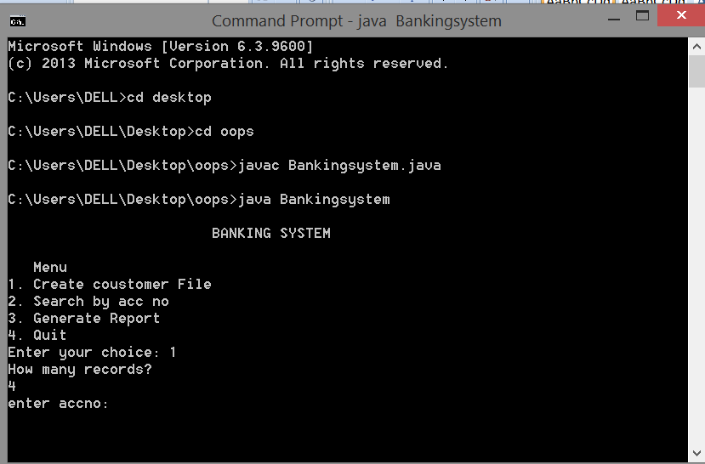

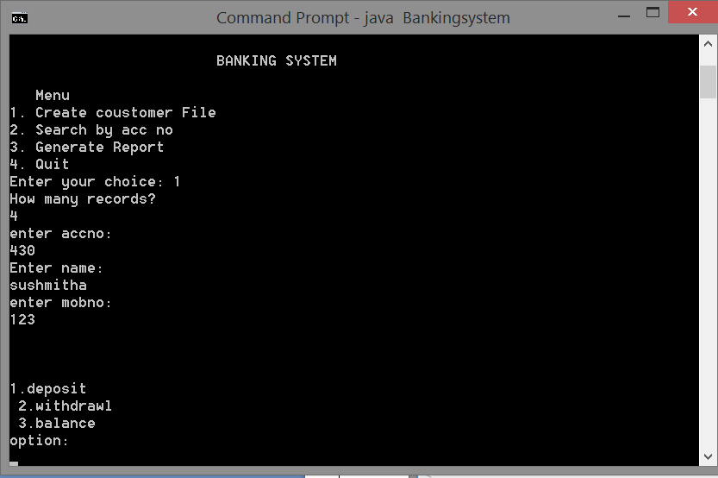

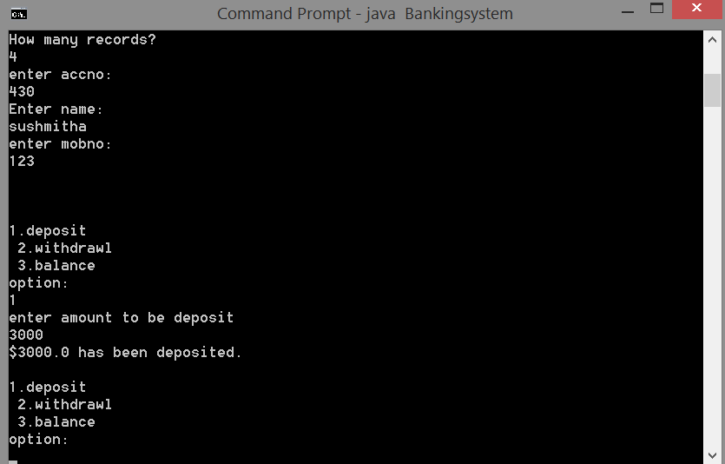

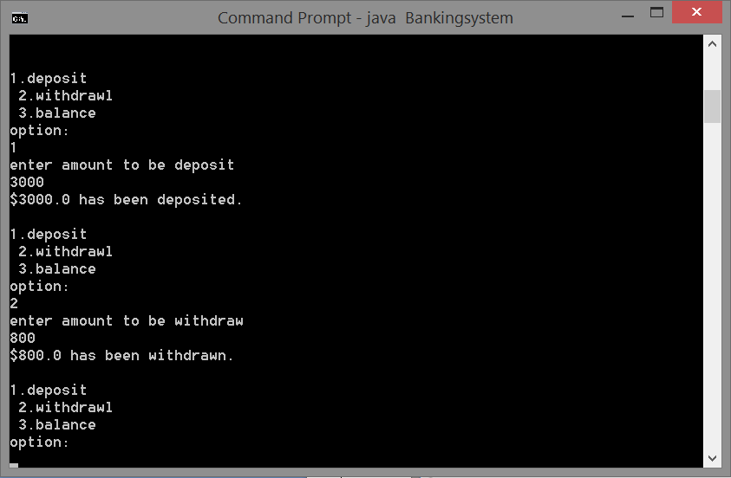 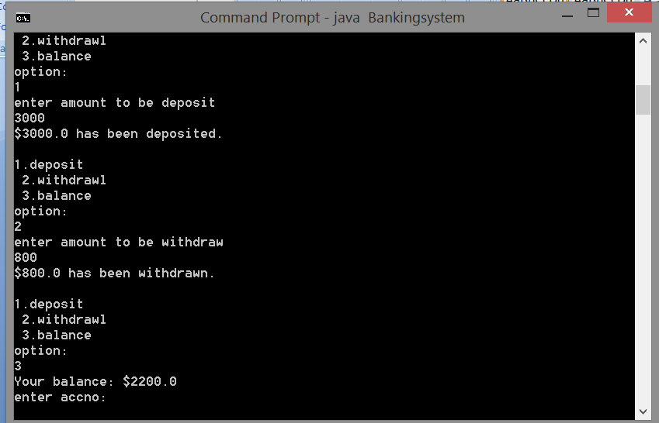

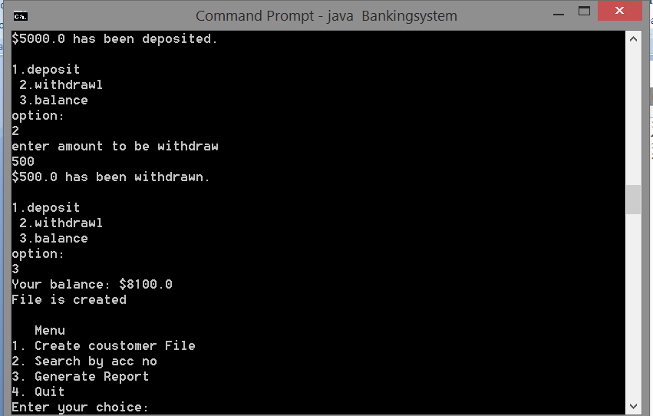

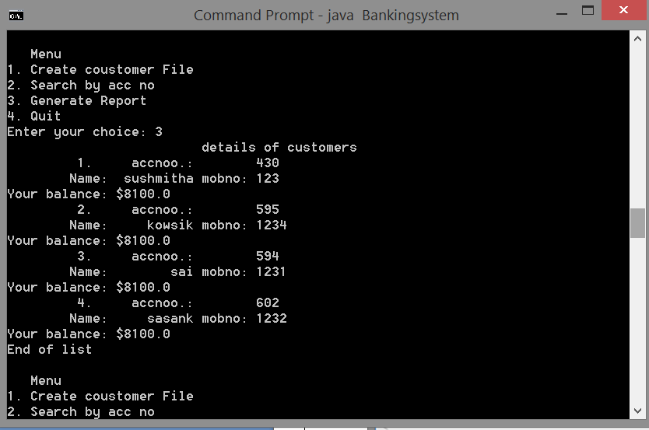

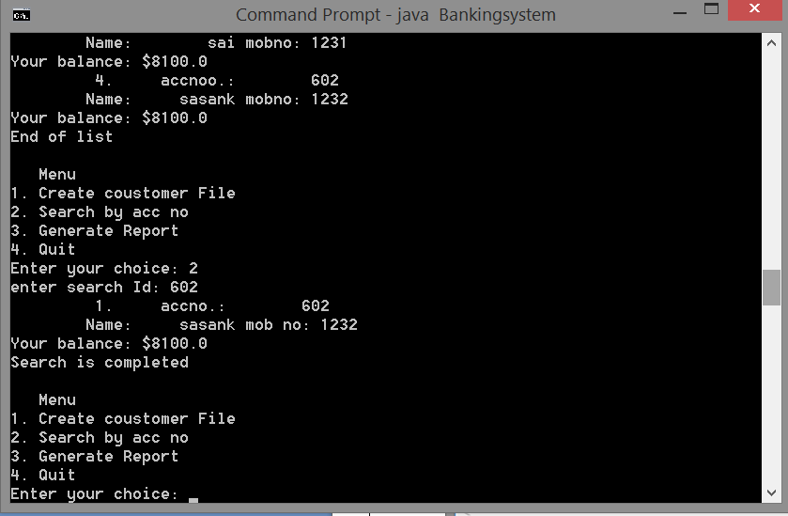

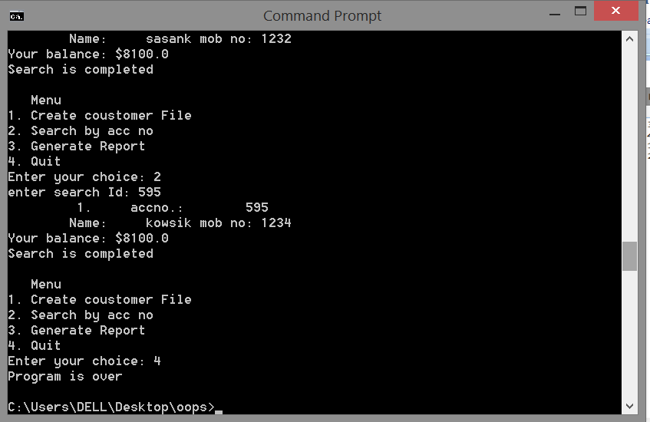

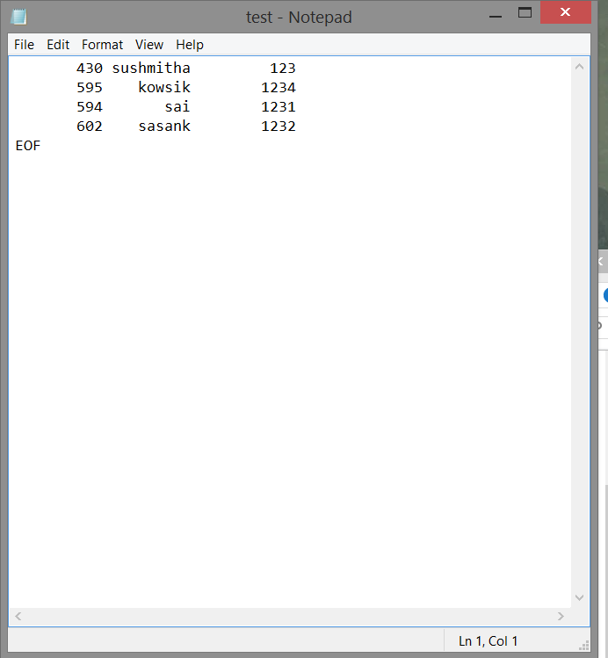

**7. Conclusion**

By using this program we can easily handle the banking system details. By this we can easily enquire the details of their account. Hence, the desired output as per the given task is obtained

**REFERENCES**

* Henry F Korth, Abraham Silberschatz, ‘’Database system concepts’’, McGrsw-Hill Internation editions, Computer Science Series (1991). Second Ed.
* Software Engineering ,McGrsw-Hill Internation editions.
* [www.slideshare.net](http://www.slideshare.net)
* [www.google.com](http://www.google.com)
* <http://www.gktoday.in/reference/brief-history-of-banking-in-india/>
* <http://en.wikipedia.org/wiki/Banking_in_India>